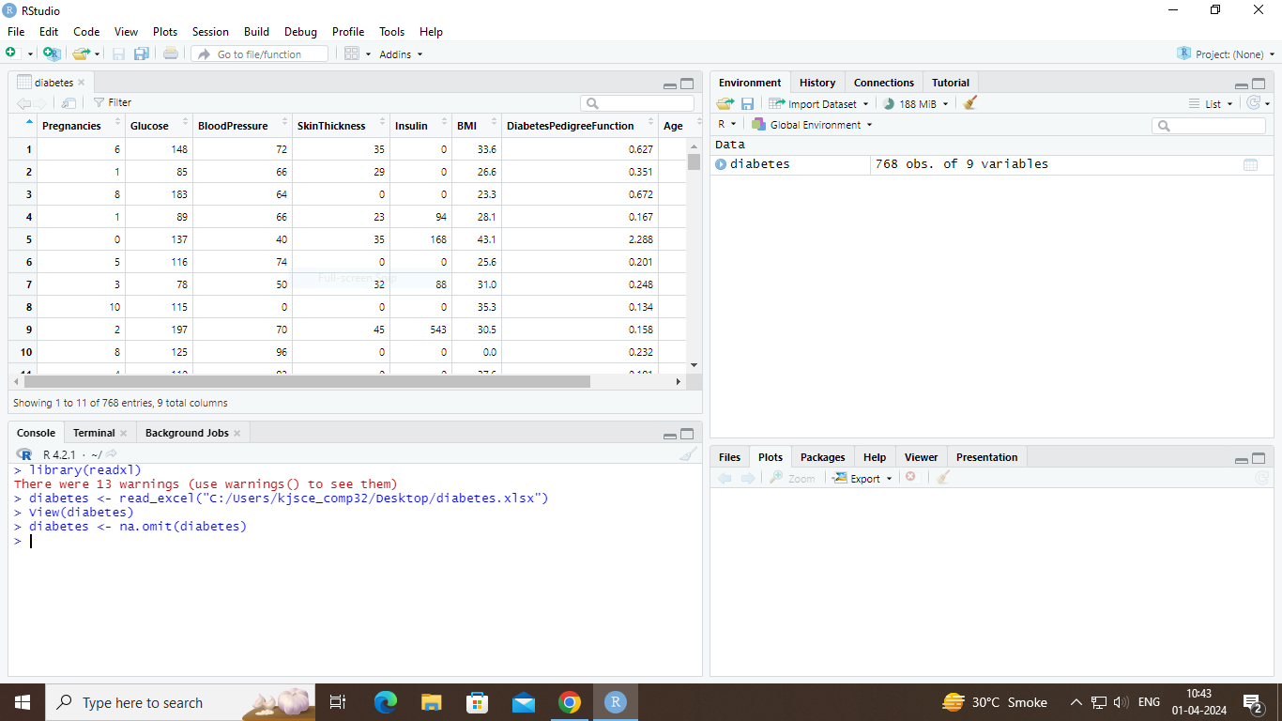
> lin.svm.diabetes <- svm(Outcome~. , data = diabetes, kernel = "linear", cross = 10)
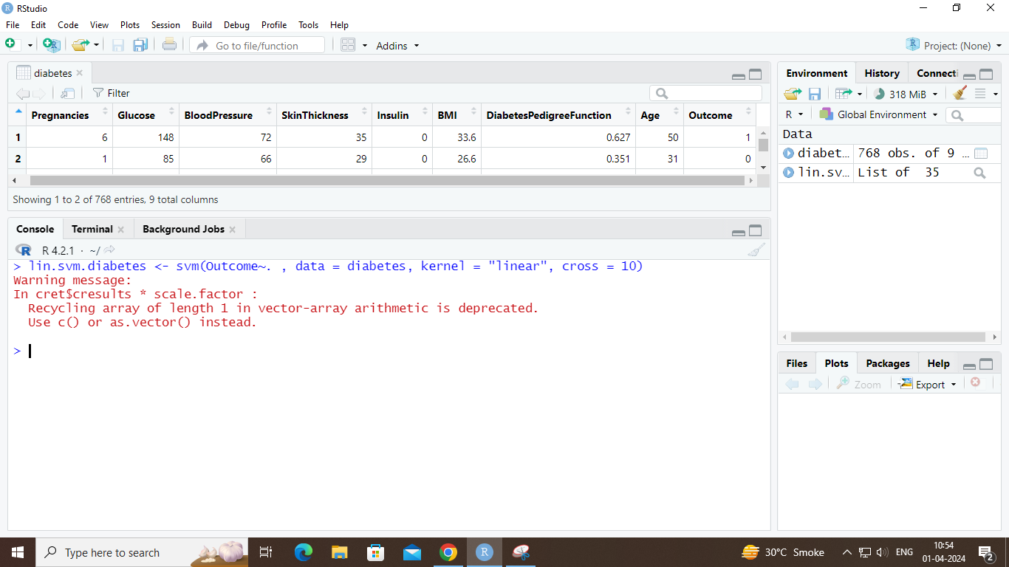
> lin.svm.diabetes
